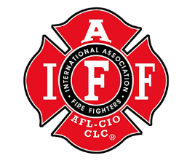
LOCAL 1817
Meeting Agenda 11/2/2021

- Attendance:
Anders, Gordon, Kerley, English, Backus, Jeffs, Tomasello, Cummings, Manning, Matson, Silver, Ede, Miller, Swillinger, Merril, Lockwood, Clark, Nichols, Cardinal

- Meeting Call to Order:
18:08 - Anders

- Treasure Report:
2022 Budget Proposal
-Kerley
Budge proposal is posted under “members forum” on the website.

- Old Business:
Vaccine Mandate

- New Business:
Civil Service questions – Merril/ Anders

- Good to the order:
Seattle Stair Climb 2022
Calhoun Thank you card
Student Chase Fettuccini baby and mama are doing well. -Tomajello
Physical Questions – Testing for lead instead of heavy metals. -English
Questions about “Written Verbal Reprimands”

- Meeting Adjourned:
-Motion to adjourn- Cardinal, 2nd – Miller 19:21

