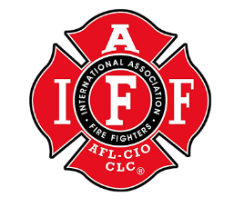
LOCAL 1817
Meeting Agenda 03/08/2022

- Attendance: Merril, Anders, Miller, Tuers, Ede, Simonsen, Allen, Cummings, Lockwood, Kassab, Clooney, Downing, English, Silver, Swillinger, Cardinal, Clark, Matson, Nichols, Jeffs, Cohee, Linville, Backus

- Meeting Call to Order:
18:01 - Anders

- Treasure Report:
Anders on behalf of Kerley
Appointment in April to reinvest the rolling accounts.

- Old Business:
N/A

- New Business:
-E-Board Elections-
Cohee to step down as vice Pres, E-board election opens in May
-D3 Recruit Academy Update
7th Recruit added due to future staffing needs
-Blakely Resignation, Final two weeks
-Staff BC/ Wildland Position
E board reviewing draft description of positions. Stay posted for opportunity to be a , part of future work groups.
-Rogue River Shady Cove talks
RR BOD meeting this week to initiate cooperation, still uncertain of what it all looks like.
Shady Cove, less known and in the more distant future.
-Bancroft retires, fair amount for potential movement. Keep an eye out for some OT, try , to help out if you can.

- Good to the order:
Updated emails/ Contact Info -Miller
Ask if you are interested in the E board, potential for shop steward.
If anyone has any talks or info about the academy, keep Swillinger and Bailey informed. Stay tuned for opportunities to help them out.

- Meeting Adjourned:
Kassab- Miller 1832

