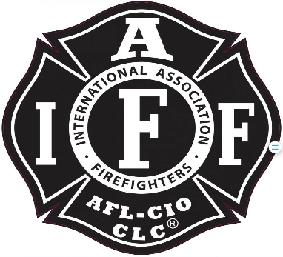

Rogue Valley Professional Fire Fighters
IAFF Local 1817

Minutes - Union Meeting
September 13, 2022 @1800 Via Zoom video-conference
ATTENDANCE
E-Board Members Present: Brian Anders, Brian Simonsen, Eric Merrill, and Travis Linville
Members Present: Rob English, Michelle Frazier, Dan Mahar, Jesse Kalman, Alex Cummings, Allyson Jeffs, Cole Hornbrook, Javier Lopez, Kendra Pinnel, Jared Hooper, Aaron Backus, John Hull, Manny Gobel, Evan Caldwell, Ian Kassab, Jason Allen, Ben Kennedy,, Mark Tomasello, and Brian Cohee.

The meeting was called to order by Brian Anders @ 1803

Budget Update:
Treasurer Merrill provided a budget update to the local. $114,000 in the primary checking. $60,000 maturing in November. Eric stated he is trying to add the budget to the union website. Secretary Linville can add monthly snap shots to the website and will be working with Merrill to provide an auto updating link to the budget.
Updates from the E-Board:
Brian Ander (1810): Mandatory and OT Policy is a joint policy with the Union and the District. Changes are agreed upon by both parties. Everyone has seen the effects with the positional mandatory that has been taken place. Captains have been getting a majorities of the mandatory. Shout out to the individuals who volunteered to be place on the mandatory list for a rank they don’t officially hold (AIC Captains). What can we do to help alleviate the mandatory? One list for all members? If they can fill the roll it goes to them, and they will be cycled to the bottom of the list.
The group discussed the impacts that the wildland division had on the district especially to the Captains.
No incentives while working on the Wildland (Brush 21), only on the FLSA “Engine” side. However, the District is giving the %10 Special Assignment to members working on Brush 21.
E-Board will begin discussion for the 2023 wildland season. Creation of a list similar to how the FF role was filled for the 2022 season, was a suggestion.
Maintaining 3 off per shift is a must.
How do we fill call back with our current CrewSense software? Does the District give priority to members who go in and take the time to fill out dates for auto accept?
Aaron Backus: Does the district give money ($50-$100) to help promote people to work overtime before it gets to mandatory status?
Promotions: D3 celebration coming up soon.
Ben Kenney (1913) wanted to get a social gathering schedule for the members and their families. More to come on that.

Good of the Order:
Mark T (1915): Remember the local negotiated for three members off per day, if we start bargaining for other things. The district may want to go back to 2 off if the local is raising big issues with moral and mandatory.
Aaron Backus: Make sure everyone is checking their paystubs. The district overpaid him and now his next paycheck will be very small.
Ian Kassab: How do we get members in the right roles sooner. How does our current requirements align with our current processes. (AA Degree for Captain, AIC Engineer for AIC Captains).
Jason Allen: Local 1817 for teams for better communication avenue for the Local.
Mark T: Each engine should carry $100 of union money to be spent on areas of opportunities for the community. Will be placed on the November Budget Meeting for a request.
Brian Anders: Reach out to E-Board members for any of your union needs.
Adjournment:
Travis Linville makes a motion to adjourn the meeting @ 1931
Eric Merrill 2nd the motion. No opposition noted.
Meeting Adjourned @1931 by Presiden

Approved by, Submitted by,

________________________ _______________________
President Brian Anders Secretary Travis Linville

