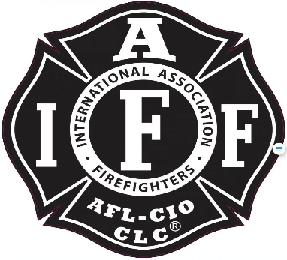

Rogue Valley Professional Fire Fighters
IAFF Local 1817

Minutes - Union Meeting
January 26, 2023 @1800 Station 22/ Zoom videoconference.
ATTENDANCE
E-Board Members Present: Brian Anders, Brian Simonsen, Eric Merrill, and Travis Linville
Members Present: Scott Downing, Rob English, Andrew Bates, Stephen Ede, Will Clelland, Jared Hooper, Jason Allen, D4 (Eli Buma.), Manny Gobel, Cody Clark, John, Hull, Cole Hornbrook, Junior Osorio, TJ Lockwood, Neil Clooney, Jared Nichols, Bryan Cohee, and Jacob Petty.
The meeting was called to order by Brian Anders @ 1801
Approval of Minutes:
Motion to approve minutes by Scott Downing. 2nd by Travis Linville
Budget Update:
Eric Merrill- See budget breakdown. Donation to Cory Fost Fund
Updates from the E-Board:
Brian Anders-
Community Care Supervisor- Admin is moving forward with that position.
Wildland Unit for this summer- Is the value of the program worth the challenges that the line faces with OT and movements. Chief Hussey does still believe the value is there and is important in moving forward with potential funding for the area. The state has 75 apparatus and D3 could potentially interface with one of those engines. Both E-Boards of cognizant of the impacts and know that the up and coming move up Captains in the process of training. Looking at different models for staffing HB21.
Alliance Meeting- With the increased call to service and the cost of providing service is going to become a challenge. The primary goal of the alliance is to maintain service to our community into the future. Rogue River and D4 realize the Fire and Life Safety Program could share the services provided. No talks of mergers.
Personal Appearance Policy – Periodic review. The review was based on recognition that a lot of policies were created around the same time with no mechanism to review these policies in a standard interval. The policy has adapted to current socially accepted norms.
Paid Leave Oregon – See Stacy’s email. Demand to bargain over the cost breakdown with the alternative plan. Reach out to Anders if you would like to know more about the lawyer’s reaction and info.
Jason Allen - D4’s First Meeting for Negotiations. Setting ground rules and getting to know each other. D4 is hiring a new Fire Chief and how does that affect negotiations. Sounds like Winfrey will stay for negotiations.
Brian Anders - Negotiators and results. Eli and Taylor redrew from negotiating. Nick and Austin will be negotiating with Jason Allen. Looking for members who are interested in learning the roles of the E-Board.

Good of the Order:
Jared Nichols – Coffee Update. Current budget is $6,000/ year (includes coffee, creamer, sugar)
Muertos: $6.50/lb cost difference 295.00 to date and $421 to date dollar difference with Mollelos.
Travis Linville – Radio update. Portables possibly coming in 2023.
Brian Anders – Cory Fox union donation. Shout out to Ben Kennedy and Brian Simonsen for seeing the need and getting it done.
TJ Lockwood – Lorin Myers still working through a lot. Going to be a hard couple of months. Reach out if you would like to.
Jason Allen – Shout out to E-22 C-Shift for the victim save and removal. Still alive as of this meeting.
Adjournment:
Motion to adjourn by Scott Downing and 2nd by Jared Nichols.
Meeting Adjourned @1720 by President Anders

Approved by, Submitted by,

________________________ _______________________
President Brian Anders Secretary Travis Linville

