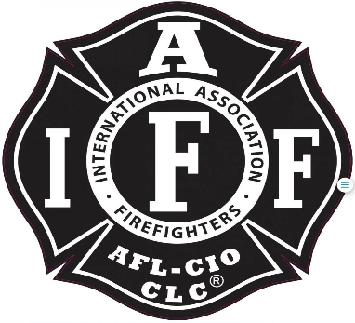

Rogue Valley Professional Fire Fighters
IAFF Local 1817

Minutes - Union Meeting
March 14, 2023 – White City Station/ Zoom 1800
ATTENDANCE
E-Board Members Present: Brian Anders, Brian Simonsen, Eric Merrill, and Travis Linville
Members Present: Rob English, Scott Downing, Kendra Pinnell, Michelle Frazier, Jared Hooper, Junior Osorio, Allyson Jeffs, Nick Fitzpatrick, Colin Lee, Sam Franklin, Ian Kassab.
The meeting was called to order by Brian Anders @ 1804
Approval of Minutes:
Nick Fitzpatrick make a motion to approve the January meeting minutes. Ian Kassab 2nds. Meeting minutes adopted and approved. No objections.

Budget Update:
Eric Merrill- See budget breakdown on the Union website.
Updates from the E-Board:
Brian Anders-
Paid Leave Oregon:
Update regarding District decision to go with an alternate plan the is different from the state. Advantages including to shop the private market for a better rate. Same benefits but possibly less than the %1 that the state is deducting. Demand to bargain was sent to District. It included that a discussion has to occur about the impacts to the Members.

Additional .5% in COLA proposal:
This is to offset the increase in Paid Leave Oregon.
Hiring Process:
Update regarding the hiring process. Chief Hussey understands the likelihood of Medford Fire potentially hiring some of our candidates that high up on our list. The amount of people hired is still undetermined due to unknown potential vacancies.
Community Care Supervisor:
Admin is still developing the job description and will send over in the potential week. Admin has confirmed it is top priority.
Wildland Program for the summer:
Discussion is focusing on the impacts of taking the personnel off the line. We realize there were some anomalies regarding the impacts that occurred last year.

Nick Fitzpatrick:
Negotiations are still underway. Wages are being discussed and Paid Leave Oregon. Next meeting still undetermined. Chief Winfrey is staying on for the District side of E-Board. Offer for next Chief is Travis Krume. Thank you to Jay Allen for assisting with negotiations.
Brian Anders:
May meeting will include nominations for Secretary and Treasurer. All who may be interested shall make themselves known. Training for potential and current E-Board members is starting to kick back off and the E-Board will be looking for opportunities to go to training.

Good of the Order:
Brian Anders: The Union received a thank you letter from the Fox family from the donation giving from the Local.

Adjournment:
Motion to adjourn the meeting by Scott Downing and 2nd by Nick Fitzpatrick.
Meeting Adjourned @1831 by President Anders

Approved by, Submitted by,

________________________ _______________________
President Brian Anders Secretary Travis Linville

