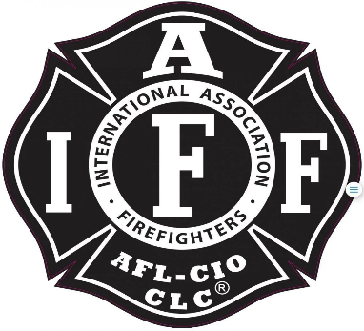

Rogue Valley Professional Firefighters
IAFF 1817
Special Meeting December 14, 2023 1800 Via Zoom/ White City Station
Called to Order: Brian Anders 1803
Attendance:
Eric Merrill. Jason Allen, Joey Forrest, Patrick Baley, Garrett Byrd, Allyson Jeffs, Rob English, Brian Simonsen, Travis Linville, Levi Swillinger, Court Gordon, Ben Kennedy, Andy Cardinal, Evan Caldwell, Alex Cummings, Collin Lee, Clayton Mattson, Trevor Patterson, Nate Smith,

Brian Anders
transfers control of the meeting to Brian Simonsen
Brian Anders
makes a motion to amend Article 2 - Jurisdiction in the By-Laws to include the Training Lt. to Article 2.
Andy C Seconds.
Travis Linville
Provided a reading of the article as it is currently written and then the proposed change.

Brian Simonsen tables the motion for January’s regularly scheduled meeting.
Rob English inquired about the Training LT’s being plural in the change,
Anders assured there is only one but adding plural as to cover any potential additional training Lt’s.
Evan Caldwell makes a motion to adjourn,
Eric Merrill Seconds with no objections.
Brian Simonsen adjourns the meeting meeting at 1815

________________________________ __________________________
President Brian Anders Secretary Travis Linville

