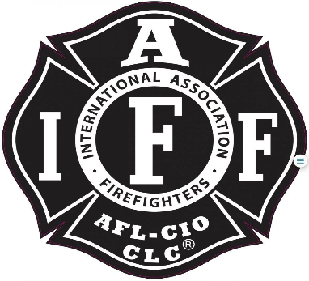

Rogue Valley Professional Fire Fighters
IAFF Local 1817

Minutes - Union Meeting
April 8th 2025, at 6:00 PM, Via Zoom videoconference
ATTENDANCE
E-Board Members Present: Brian Anders, Brian Simonsen, Eric Merrill, Travis Linville
Members Present: Cole H, Chad L, Scott D, Levi S, Kenny H, Andrew C, Jason A, Joey F, Evan, Manny, Bryan C
Meeting Called to Order 1807
President Anders has passed the meeting to Simonsen at 1809.
Biran Anders move to un-table the motion that was presented on the March 11th meeting regarding adding the CCC to the by-laws. Travis seconds to un-table
Kenny calls point of order at 1814
VP Simonsen acknowledges Kenny.
Kenny pointed that VP Simonsen misspoke when he said motion is passed with atleast a 2/3rd vote. Only a simple majority was needed.
VP Thanked Kenny for the point.

Action Items:
40.1 Amending By-Laws to include Community Care Coordinator

Discussion Items:
Brian Anders started discussions with pointing out that a member of the Local reached out to him stating that they have concerns with discipline being on the CCC job description. Anders pointed out that same authority extends to Fire Captains as well.
Anders added another concern that Admin would be steering this job/ individual in any direction they wanted. That would be true if this position was not protected under the collective bargaining agreement. The E-Board would be able to provide protection or add influence to the job description if they are represented.
Levi S asked Jake Petty about the current direction or future of Community Care. Levi stated the fire personnel have been in the dark throughout the duration of the program.
Jake Petty is wanting to provide an update on the program during the supervisors meeting but was unable to do so. Jake continued to add current insights on the on-boarding process, and the direction of individuals when they get hired. Building out the capabilities of Comm Care to provide services to individuals in need. He would like to see more tailored care involving the pt’s healthcare providers to not duplicate efforts and provide more relevant care. Continue to build out the fall prevention program. 911 response is a priority along with community engagement.
Levi asked Jake if he wanted to be in the union and asked Jake what he feels the District vision is for his department and his desires with the program.
Jake provided more insight into the current model and how the comm care programs provide a serviced to the community and reduce the call volume.
VP Simonsen wanted to re-direct the discussion towards whether to amend the by-laws.
Jake voiced that he would like to see this position in the union and provided his rationale behind that.
Anders added that he can appreciate the position being protected under the local to make decisions that this position will have to make.
Simonsen calls for a vote.
Secretary Linville recorded the votes.
10 Yes
3 No
Vote Passes to add the CCC to the by-laws.
Simonsen passes the meeting back to Anders.
By-Laws will have to be sent to the National IAFF.

Adjournment:
Brian opens the meeting for a motion to adjourn. Bryan C makes a motion to adjourn. Jason seconds the motion.
Meeting is adjourned at 1845

Approved by, Submitted by,

________________________ _______________________
President – Brian Anders Secretary - Travis Linville

