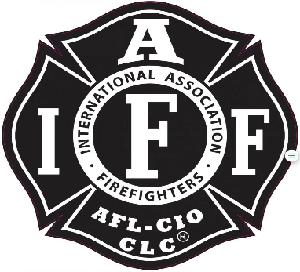

Rogue Valley Professional Fire Fighters
IAFF Local 1817

Minutes - Union Meeting
January 14, 2025, at 6:00 PM, Via Zoom videoconference
ATTENDANCE
E-Board Members Present: Brian Anders, Brian Simonsen, Eric Merrill, Travis Linville
Members Present: Mark T, Manny G, Cody C, Kendra P, Junior O, Garrett B, Jared N, Andrew B, Stephen E, Charles S, TJ L, Derek P, Scott D, Dammon H, Levi S
Meeting Called to Order 1805
Approval of Minutes:
Mark T made a motion to approve the November 2024 meeting minutes. Jared N seconds. All in attendance approved.
Action Items:
50.1 Discussion opened to get final approval on the numbers of apparatus receiving the cash. Mark provided further explanation on the vote that occurred that included all 5 engines, BC, 3 DFMS, and Community Care. Jared makes a motion to change the total number of units from the 10 apparatus to the 5 engines. 4 D3 Engines and 1 D4 Engines. Eric seconds. Motion carries unanimously. Big shout out to Mark for getting this idea off the ground and laying the ground work for an awesome way for Union members to help the community.
50.2 Coffee Talk- Max of $500 for fiscal year 2025 that the union would spend to cover any overages. Jared makes motion for the union to cover no more than $500 for fiscal year 2025. Mark T seconds. Motion carries unanimously with no objection. Muertos coffee is coming to the fire house. Thank you Jarred for all the time and energy putting this project together.
50.3 Discussion of standardizing the Union’s gift to retirees. Send ideas to the Union Secretary for sharing during the March meeting. Thank you, Levi, for getting this idea moving forward.

Discussion Items:
Budget Update: Eric provided the bi-monthly update. All current amounts are posted on the Union website.
E-Board Updates: Union E-Board will be meeting with the district on Thursday for a 2025 update. The E-Board will be bringing to the table ideas to boost morale. There are some non-cost items that would be a good morale booster. Reach out to any E-Board members with items you would like brought up.
Ongoing discussions with policy changes with D4.
Old Business:
Unwritten Rules: Provide a pathway to newer firefighters of D3 cultural dos and don’ts. Send all ideas to the Union Secretary. The list will be provided at the March meeting.

Good of the Order:
Jared asked if there is any update with J-Ville. Anders stated no news from them.
Anders stated the IGA is now live. Jared asked if D5 members have been invited to the end of year party. Nothing has been extended to them as the party is to celebrate D3 members from 2024.

Adjournment:
Mark T makes a motion to adjourn the meeting. Jared N seconds. No objections. Meeting is adjourned at 1905.

Approved by, Submitted by,

________________________ _______________________
President – Brian Anders Secretary - Travis Linville

