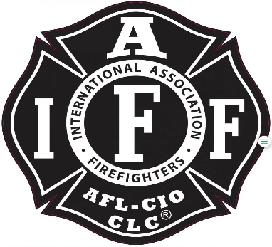

Rogue Valley Professional Fire Fighters
IAFF Local 1817

Minutes - Union Meeting
May 6th, 2025, at 6:00 PM, Via Zoom videoconference
ATTENDANCE
E-Board Members Present: Brian Anders, Brian Simonsen, Travis Linville
Members Present: J Hooper, Niel C, Jason A, Bryan C, Mark T, Joey Forrest, Garret B, Scott D, Dammon H, Chad L, Levi S, Court Gordon, Ethan M, TJ L, Clayton M, Derik P, Adam C, Jesse K, Jared N, Kendra P.
Meeting Called to Order 1806
Approval of Minutes Jason makes a motion to adopt the meeting minutes. Second from Dammon H. All in approval.
Action Items:
40.1 Determination of Salaries for E-Board Members: Keep the salaries at the same percentage that they are currently. 12% President, %10 VP. Sec and Tre at 8%
40.2 Nominations for Treasurer and Secretary:
Treasurer: Levi S nominates Joey F. Joey accepts. Bryan C nominates Eric M. Derik seconds the nomination for Joey. Eric M respectfully declines.
Secretary: Jared N nominates Neil Clooney. Neil accepts. Simonsen nominates Eric M. Eric respectively declines.
40.3 Lorin Meyers Compensation
Court provided some back story to how Lorin has been providing exceptional support to us and our neighboring agencies. The topic of income came up around the coffee table with Lorin with the passing of his wife. Court makes a motion to gift Lorin $200 a month until separation from the District. Bryan C seconds the motion. Open the floor to discussion. TJ provided some context with CommCare potentially providing Lorin some support to help bolster his situation. Mark asked if anyone had reached out to see what Lorins needs are. Court provided that money will help his immediate needs as he limits how much he drives his car due to low income. Motion passes with 14 yes/ 1 no/ and 4 abstain.
40.4 Station Logo Design Money: Ben would want to have a one time expense of $2,000 for station logos ($500 each station). The money would be for design work only. Mark asked what the money would cover. Derik provided context on the money would cover the design. Scott added that maybe we should slow down a little and get the District’s approval. Scott added we should get the approval to move forward with a design and get the District’s buy in and move forward with using some of their money. Clayton added that potentially we don’t need to spend up to $2,000 dollars. Hooper asked if D3 has ever considered logos on the engines. Tabled and will be placed on the July Agenda.
40.5 Donation to Rogue Girls Fire Camp 2025: Kendra provided back story to the Rogue Girls Fire Camp. $500 is what has been donated in the past. Simonsen asked if other locals donated. Kendra added it is around $500. Kendra makes a motion to donate a one-time payment of $500. Garret B seconds. Motion passes: with 14 yeses, 0 No’s, and 3 abstain votes.

Discussion Items:
50.1 Treasurer Update: Checking: $134,772, Savings: $5,065, Investments: $58,245. Donations this month: D9 School Foundation, Crater Foundation, and Audrey Robinson (crater wrestler.
50.2 E-Board Updates: Not provided due to call.

Old Business:
None
Good of the Order:
70.1 IAFF Lapel Pins will be coming to everyone.
Adjournment:
Clayton makes a motion to adjourn the meeting; Jared seconds the motions. Meeting adjourned @1900

Approved by, Submitted by,

________________________ _______________________
President – Brian Anders Secretary - Travis Linville

