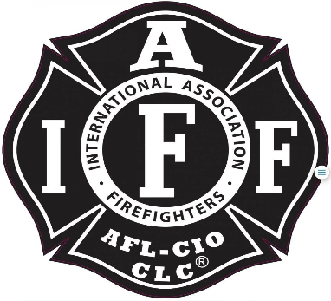

Rogue Valley Professional Fire Fighters
IAFF Local 1817

Minutes - Union Meeting
November 6th, 2025, at 6:00 PM, Via Zoom videoconference
ATTENDANCE
E-Board Members Present: Brian Anders, Brian Simonsen, Neil Clooney, Joey Forrest
Members Present: Andy C, Garrett T, Bryan C, Ben K, Jason A, Evan C, Mark T, Cody C, Dan M, Aaron B, Stephen E, Colin L, Derik P,
Meeting Called to Order 18.05
Approval of Minutes September’s meeting was motioned to approve by Mark T and seconded by Garret T
Action Items:
40.1 Ben K requests $150 for logo design, per station, that Tesha will help facilitate. This is a one-time request to create a mascot for the union per firehouse. Each house will decide on appropriate logo, demonstrating station pride and use it as they see fit. Ben will be contacting each station to help them get their designs to Tesha.
Mark T mentioned that from the leadership lunch it seemed Admin could be supportive of backing this and once the designs are in place we could look into leveraging that to put them on engines, drill tower etc.
Mark T second the motion.
Motion carried 16 yes, 0 no, 1 abstain
40.2 Mark T asks for $570 to place extra sleeping bags in our deployment totes at the stations. This originally was approved by Chief McBride, but through accidentally underordering and choosing a better-quality sleeping bag the budget improved. Rather than go back to the Chief for more money, it’s proposed that the union pays this one-time expense for the benefit of its members.
Ben K second the motion
Motion Carried 13 yes, 3 no, 1 abstain
40.3 Kenny H grievance with the district for policy not being followed for overtime callback. The body is working towards resolution with the district.
As an educational piece all grievances on contractual policies must be filed within 14 days of the occurrence.
40.4 Bryan C and Mark T had a capstone project to complete their degrees that were paid for by the district. The district asked them to do an Operational Agreement Study between Fire District 3 and 5 to see what a merger would look like and the benefits of that. It was a broad study with interesting insight and received over 79 responses from line personnel from both departments. The takeaway is most of the personnel support the idea and the study is something for admin to consider in the future.
Mark and Bryan are appreciative of the support and to reach out to them with any further questions.
Discussion Items:
50.1 Treasurer Update:
The budget is posted on RogueValleyProfessionalFirefighters. Please vote to approve or disapprove. Voting is up for 10 days.
District 4 has negotiations coming up.
We have $40,000 in CDS maturing soon and Joey F has been talking with an investment firm for reinvesting the money to work harder for us. More on that to follow.
50.2 E-Board Updates:
No E-Board updates Brian A was running a call at this time.
Old Business:
60.2 Brian S explains the situation with paying Lorin $200 a month which was approved in May but has gotten convoluted since Lorin no longer provides a service to the district but still provides a service to Local 1817 members.
Aaron B suggested we place a donation box in every station for members to contribute to, this could be picked up monthly and dispersed to him.
Brian A suggested that a revote for Lorin Meyers would have to happen as too much time has passed and circumstances have changed.
Good of the Order:
Neil C is going to get some updated photos for the website from Shannon and add them to the picture cycle. IAFF stickers will be ordered soon.
Adjournment:
Neil C asked for the meeting to be adjourned, Brain S motioned the adjournment and Ben K seconded it at 19.20.

Approved by, Submitted by,

________________________ _______________________
President – Brian Anders Secretary – Neil Clooney

